Slip base system: design for safety

Yuxuan Chen 1002942587

Introduction:

The freeway poles, including highway signs, utility poles and luminaire supports, have a particular base structure. At few inches above the ground level, the pole is separated into two sections that are connected by a hinge mechanism. It forms a shear plate using two slip plates and several bolts.

This design is called slip base system. It is essentially a breakaway system for poles which limits the impact force exerting on the vehicles during collision. This system is added to the design for freeway poles for the purpose of safety.

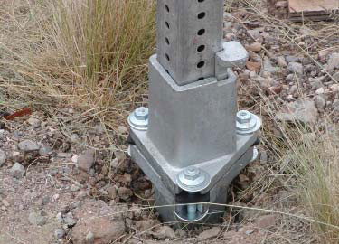Figure 1: triangular slip base
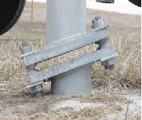Figure 2: inclined slip base

Background:

There are increasing numbers of poles on highway, and many of them are located fairly close to the traveled way. Considering that the average speed for vehicles on highway is 70 mph, it could have very serious consequences when there are roadside collisions with freeway poles under high speed, such as extensive property damage, injuries or even fatality. Studies have showed that there are increasing number of incidents of cars crashing into freeway poles. There were 20 pole accidents per 100 miles of highway, and 16 pole accidents per 100 miles of highway. [1]

Pole accidents account for 20.6 percent of total fatal accidents, and 9.9 percent of injury accidents. [1] In terms of vehicle damages, front impact accounts for 72.9 percent of the collision, while side impacts accounts for 12 to 13 percent. [1]

Slip base system:

There are two approaches that aim to reduce the Run-off Road Collision: making sure that vehicles stay on the road, or minimize the hazards of collision. [5]Slip base design is an example of second approach. It limits the accidents that are related to the collision between vehicles and freeway poles by reducing the velocity and momentum of vehicles after impact. This idea was first brought up by D.L. Howkins of the Texas Highway Department in 1960s, which allows the poles to slip off from the base after impact. The principle of the design is to reduce the change in momentum of the vehicle during collision so it can pass through the structure without severe damages. [2]

The design includes two identical plates with cut slots that are stabilized by two bolts. In response to impact force, the top plate would slide towards to same direction as the vehicles, forcing the bolts to pop out of the plates, such that the top section would be free to move.

There are several approaches to design slip base system. One type of the design utilizes wedged plates, so the slip base has an inclined angle, which makes it easier to sheer sideways, or even pass over the colliding vehicle. (figure 2)

Another more common type of design adopts equilateral triangular shapes. It has multi-directional breakaway property since that it allows the pole to separate regardless the direction of impact force. The bottom plate is connected to the foundation, while the top plate is attached to the poles. There is slot at each corner of the triangle, which are tightened by bolts. (figure 1)When impact force is applied, the shear force of the top place would cause bolts to move laterally until it exceeds the limit, causing the pole to break away from its foundation. [3][4] Hence, it reduces the resistant force that the pole might exert on the vehicle, which alleviate the effect of impact.

Restriction:

The inclined slip base system can only be effective when the angle of impact is predictable, such as divided highways. But when the vehicles hit at an unexpected angle, the poles might not break at all.

Similarly, triangular slip base system has restrictions as well. The effectiveness of the system relies on the connector bolts. If they are too loose, they might not withstand strong wind. However if it is too tight, the plates would not slip during impact.

Furthermore, since most of the breakaway poles are designed to be hit at bumper height, so they are less effective when placed near ditches, steep slopes or on top of concrete pedestal. [5]

Conclusion:

Several performance tests have been conducted. It states that most of the non breakaway poles remain rigid after the collision, while breakaway poles would generally be knocked down due to impact. Under the same collision condition, crashing into poles that remain rigid afterward would result in higher injury severity. For larger poles like luminaire supports, It shows in the report that there is 50 percent change for occupant to get injured in a non breakaway pole accident even when the crashing speed is as low as 9 mph, while the chance of getting injured is less than 50 percent for breakaway poles even when the impact speed can reach up to 50 mph. So it can be said that the breakaway system is a safer design for freeway drivers. [1]

References:

[1]: Accident Analysis – Breakaway And Non breakaway Poles including Sign and Light Standards Along Highways. Volume I: Executive Summary. King K. Mak. Robert L Msson, Ph.D.
Southwest Research Institudes, San Artonio, Texas.
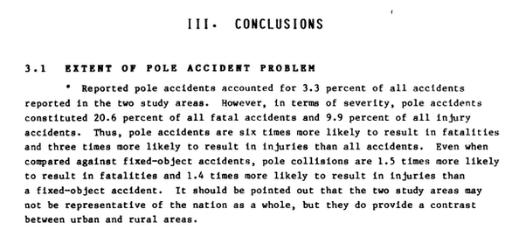
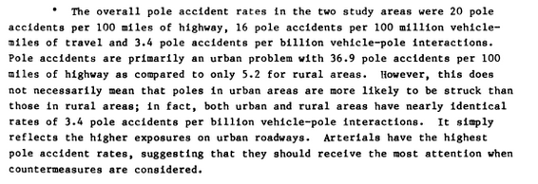
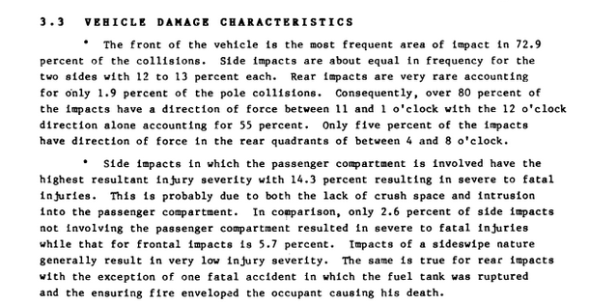

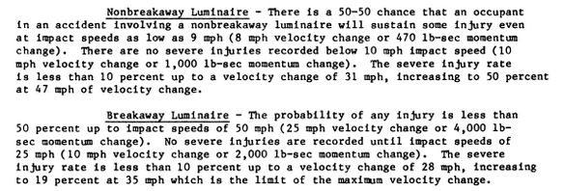

[2]: Patent US 4986698 A, AD-IV breakaway system for timber utility poles. Don L. Ivey. Jan 22, 1991
https://www.google.com/patents/US4986687

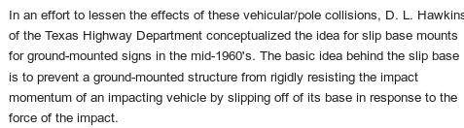

[3]: Multi_directional slip base for breakaway luminaire supports. Thomas C. Edwards, August 1967.
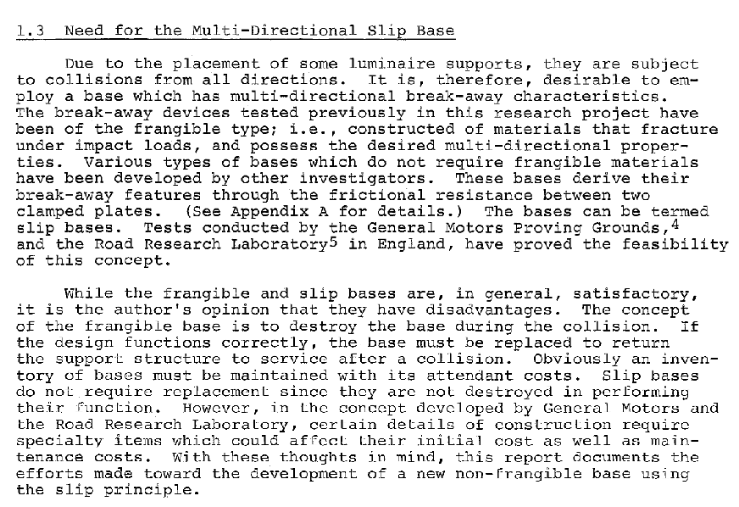
http://d2dtl5nnlpfr0r.cloudfront.net/tti.tamu.edu/documents/75-10.pdf

[4]: US 4923319 A. Breakaway connector. Clifford M. Dent. May 8, 1989.
https://www.google.com/patents/US4923319
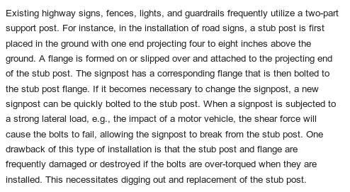

[5]: Evaluation of Roadside Collisions with Utility Poles And Trees at Intersection Locations. Todd Berry Mattox. Georgia Institute of Technology. December 2007.
https://smartech.gatech.edu/bitstream/handle/1853/19829/mattox_todd_b_200712_mast.pdf
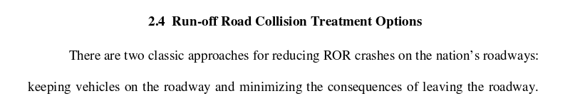
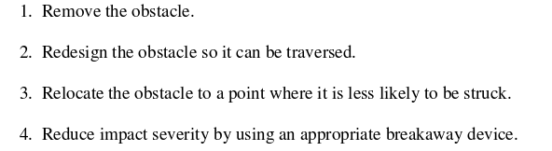
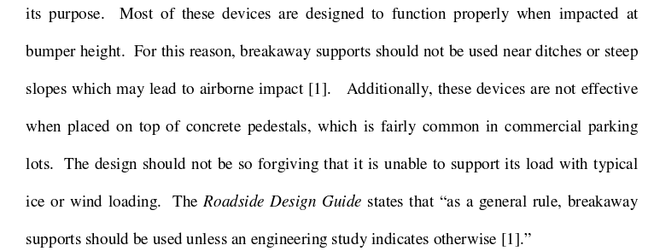

figure 1: http://safety.fhwa.dot.gov/roadway_dept/policy_guide/road_hardware/ctrmeasures/breakaway/images/fig_2.jpg

figure 2:
http://www.dentbreakaway.com/var/m_5/5c/5c8/728218/718955-inclinebase.jpg

